Ishmal Tahir

225868

BSCS 7B

**Advanced Programming**

**Assignment 1 – Exploring Open Source Software**

**WordPress**

It is a content management system based on PHP and MySQL. It has a plugin architecture and a template system. WordPress is an easy platform to work with and is flexible enough to suit different type of websites.

To install WordPress download its latest version and upload those files to the web server. Then create a MySQL database and user for WordPress. Configure to connect it to the database. The installation is complete.

In order to create a local web server for testing and deployment purposes, install XAMPP.

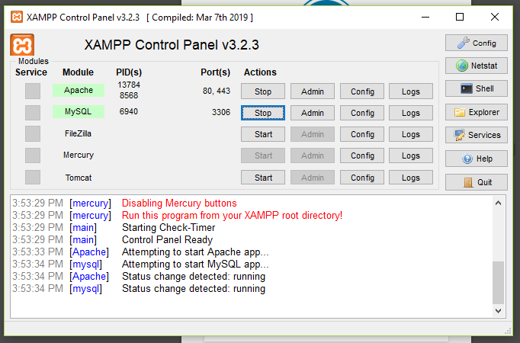



Next, login to WordPress and start making your website.

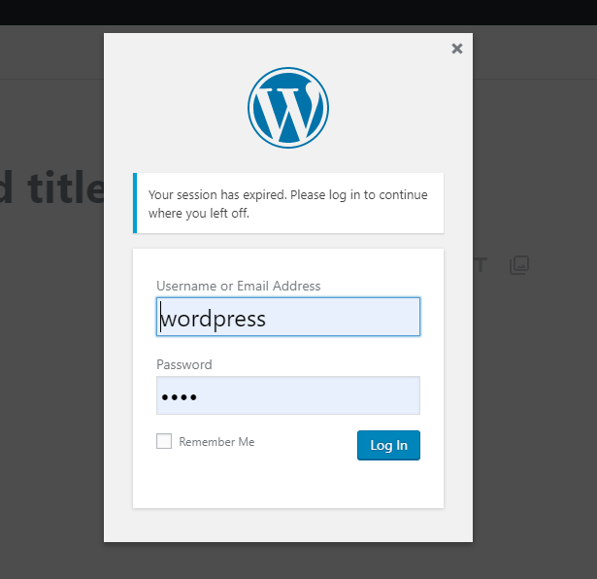

A user is automatically added to the database and the details of users can be viewed in WordPress.

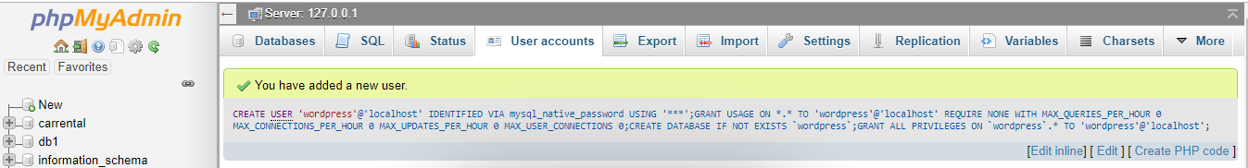

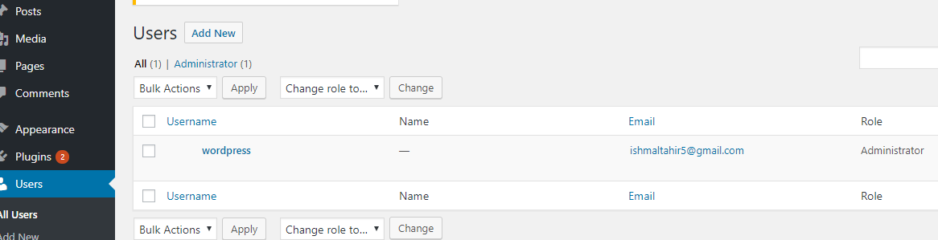

A database is made and all the required tables are added to it in order to store the information. Any changes made in WordPress automatically updates the database.

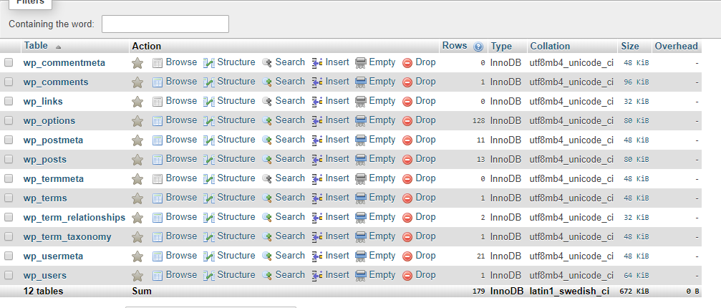

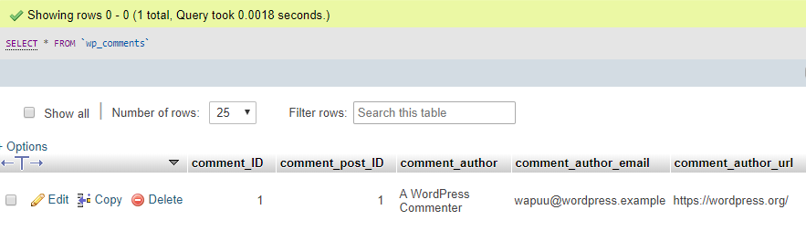

Saving a comment in database

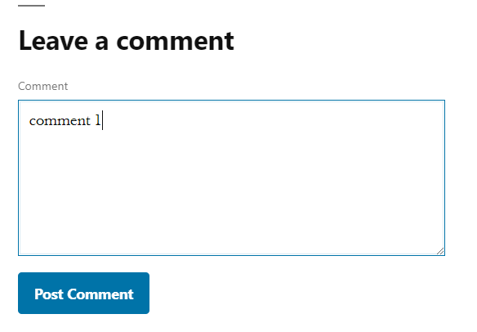

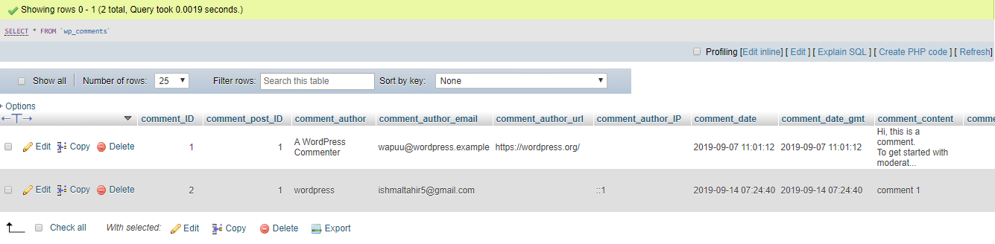



Select a theme from thousands of WordPress’s available themes and modify them according to the requirements.

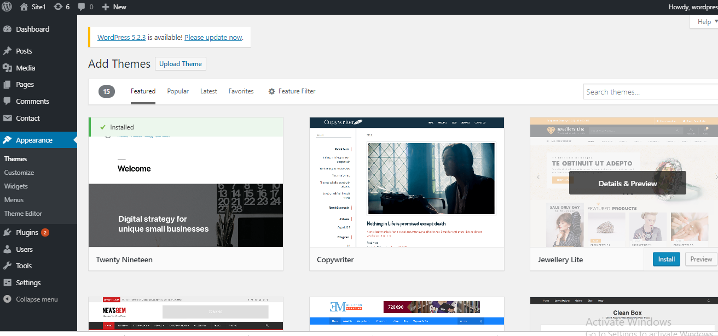

The code of a WordPress website is provided which can be changed accordingly if needed.

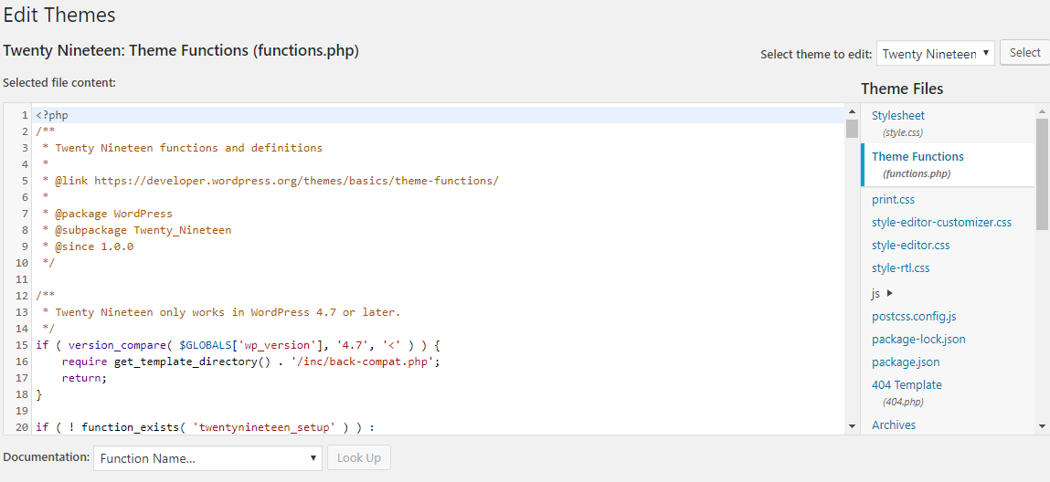

Plugins can be installed in WordPress to increase functionality and add new features to the website.

To use a plugin, install and activate it.

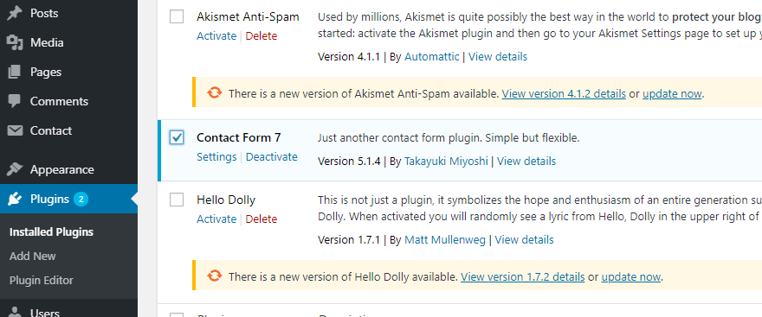

For example, after installing and then activating Contact Form 7, we can add a new contact form and select required fields.

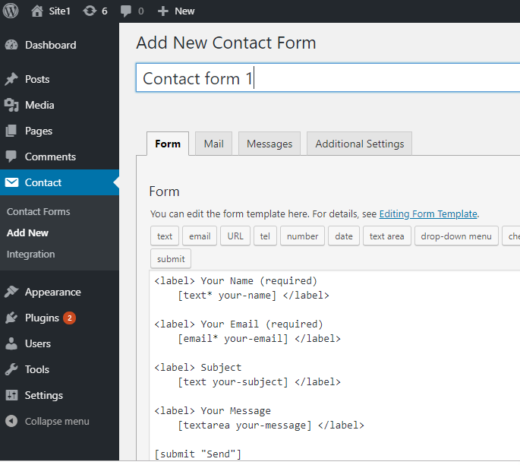

When the form is created, it generates a short code in HTML that can be pasted in text or post widget.



Add it to the website where needed.

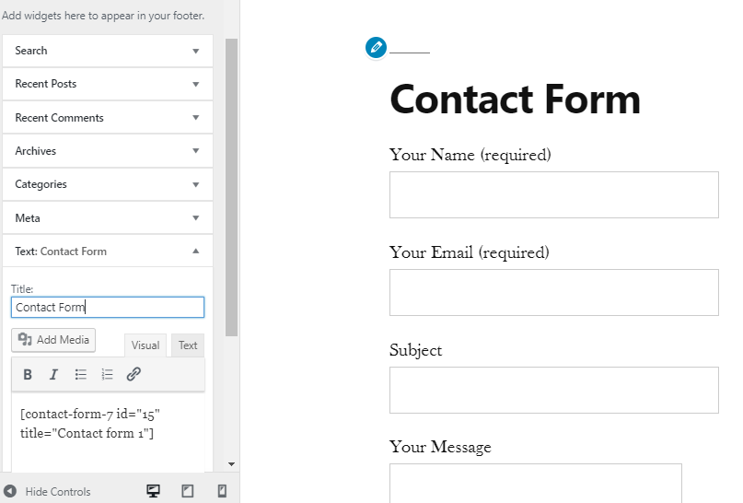

The submitted form is sent via mail. To store it in the database, additional plugins are needed.

There are many communities around the world that are responsible for making changes to the source files and keeping WordPress up to date and secure. WordPress is user-friendly which makes it a good choice for anyone wanting to develop a website.